PHASE 1 DEV HANDOFF — SSF DAILY CHECKLIST (V1)

Rought Mockups to be used as a guide: Design layout ideas. NOTES: Today’s completion remains up top of page,

Laptop View:
Find Prospects is row 1
Build Relationships and Stay Connected are row 2
Facebook Group and Growth are row 3

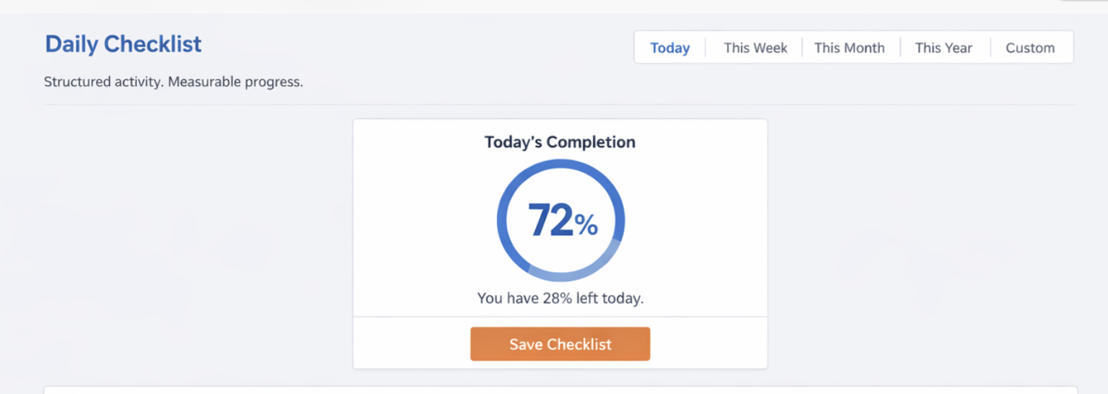

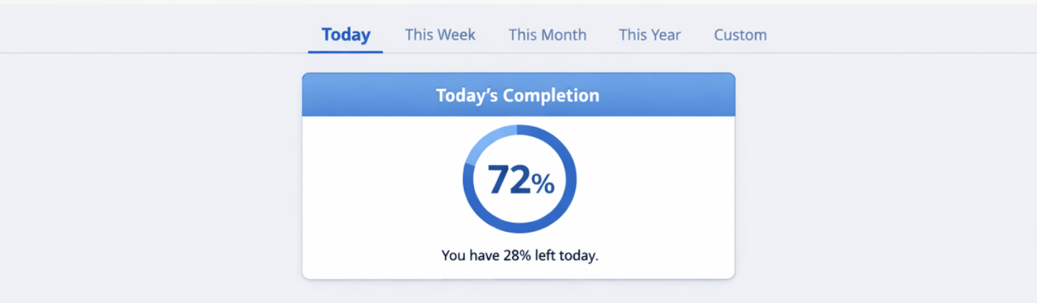

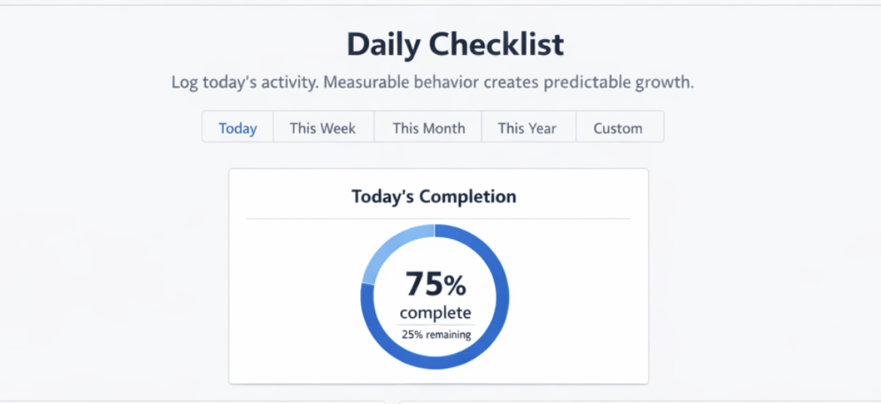

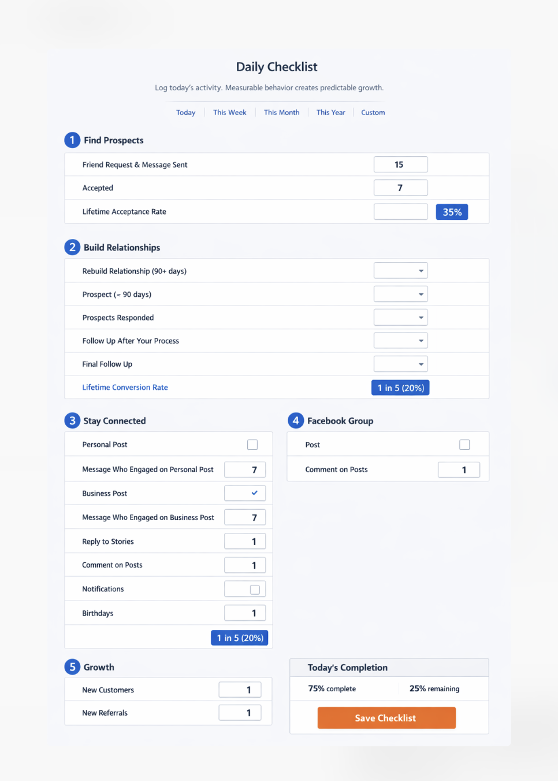

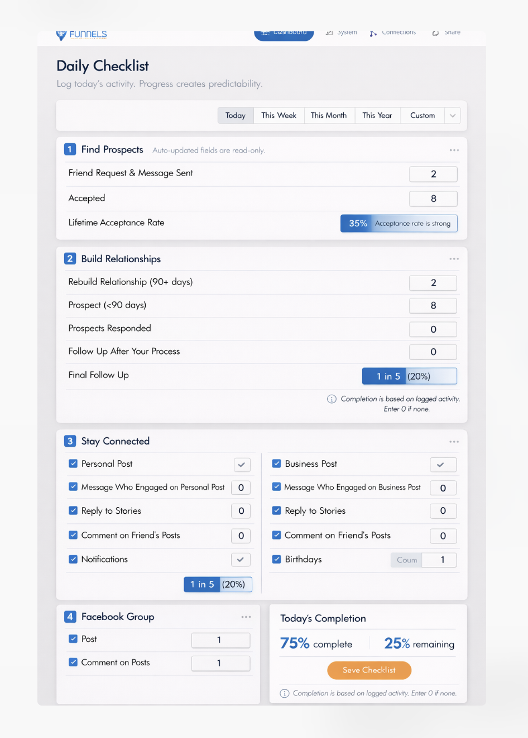

1) Purpose
Users log daily execution of the Six Sigma Funnels system.
The product provides:
- A daily log experience (default: Today)
- Reuse existing time-range filter: Week / Month / Year / Lifetime / Custom
- A Summary on the same page under the checklist (totals + progress)
- System-calculated conversion displays:
  - Find Prospects acceptance rate
  - Build Relationships conversion shown as “1 in X (Y%)”
- A visible Daily Completion %
- A static “System Complete Today” label when 100%
- No gamification
Phase 1 objective:
Users confidently complete the system daily and see measurable progress without feeling overwhelmed.

2) Checklist Sections + Tasks (Phase 1)

Section 1: Find Prospects (Auto-Fed / Read-only)
- Friend Request & Message Sent — auto number (read-only)
- Accepted — auto number (read-only)
- Lifetime Acceptance Rate — derived display (read-only)
Notes:
- These values are system-fed.
- Users must complete tasks on the Connections page to generate these numbers.
- These rows DO count toward daily completion.
- The derived acceptance rate row does NOT count.

Section 2: Build Relationships (Manual)
- Rebuild Relationship — number
- Prospect — number
- Prospects Responded — number
- Follow Up After Your Process — number
- Final Follow Up — number
- Lifetime Conversion Rate — derived display: 1 in X (Y%) (read-only)
Notes:
- Derived conversion row is excluded from completion.
- All number fields must contain a value (including 0) to count as complete.

Section 3: Stay Connected (Manual)
- Personal Post — checkbox
- Message Who Engaged on Personal Post — number
- Business Post — checkbox
- Message Who Engaged on Business Post — number
- Reply to Stories — number
- Comment on Friend’s Posts — number
- Notifications — checkbox
- Birthdays — number

Section 4: Facebook Group (Manual)
- Post — checkbox
- Comment on Posts — number

Section 5: Growth (Manual)
- New Customers — number
- New Referrals — number

3) Completion Rules (Daily)

100% Complete Day Definition
A day is complete only when:
- Every required checkbox is checked.
- Every required number field contains a value (including 0).
- Friend Request & Message Sent (auto) has a value.
- Accepted (auto) has a value.
- Blank ≠ 0.
- Derived conversion rows are excluded.
Effort counts even if outcomes are 0.

4) Task-Based Completion %

Counted Tasks
Manual tasks = 17
Auto-fed tasks = 2
Total tasks counted toward completion = 19
Excluded:
- Acceptance rate (derived)
- Build Relationships conversion (derived)

Daily Completion %
For a given date_key:
completed_tasks =
count(checkbox_true) +
count(number_not_null) +
count(auto_tasks_with_value)
number_not_null includes 0.
auto_tasks_with_value =
friend_requests_sent not null AND
accepted not null
daily_completion_percent =
(completed_tasks / 19) * 100
remaining_percent =
100 - daily_completion_percent
Display rounding:
display_percent = round(daily_completion_percent)
display_remaining = 100 - display_percent

5) System Completion Indicator (New – Phase 1 Addition)
When daily_completion_percent == 100:
Display static label at top of page:
✔ System Complete Today
Rules:
- No animation
- No celebration graphics
- No confetti
- Calm, structural confirmation only
This is not gamification.
It is structural clarity.
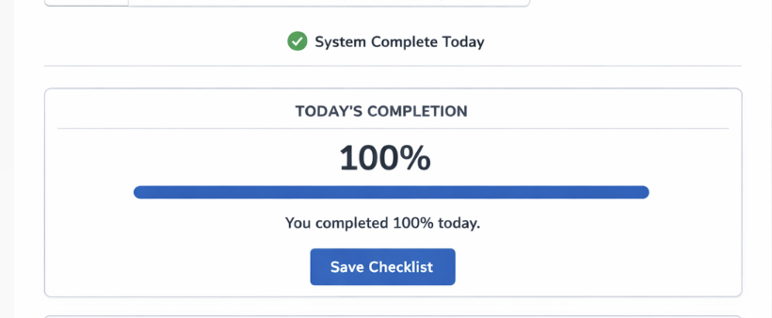

6) Helper Text (New – Phase 1 Addition)
Below checklist:
“Enter 0 if completed with no outcome.”
Purpose:
- Clarifies blank vs 0 rule
- Prevents confusion
- Reinforces effort-based completion

7) Save + Logging UX

Save Behavior
Auto-save:
- Silent on field change
- No toast on auto-save
Manual Save:
Button label: Save Checklist
Toast appears only when user clicks Save Checklist.

Confirmation Toast Copy
If 100%:
“Saved. You completed 100% today.”
If Not 100%:
“Saved. You’re at {X}% for today.”
Where:
X = round(daily_completion_percent)
No motivational pressure language.
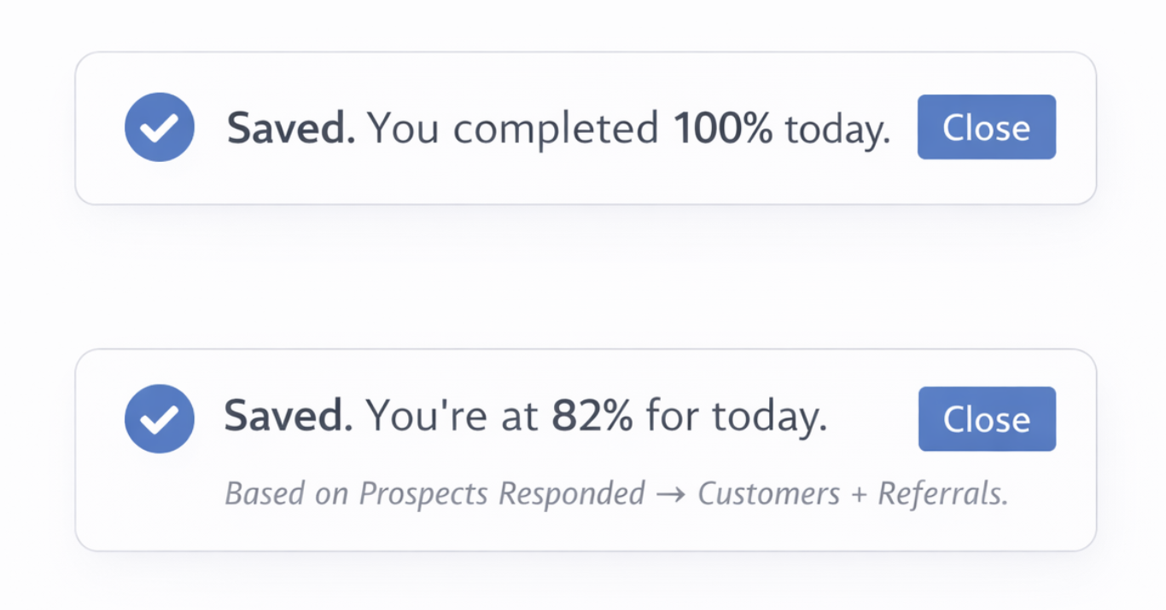

Anti-Spam Safety
If Save Checklist clicked again within 10 seconds:
- Still save
- Do NOT show toast again

Editing Past Days
Users can edit any past day (unlimited).
Edits must recompute:
- Daily completion %
- Range totals
- Derived conversions
- Summary metrics

8) Conversion Formulas

A) Find Prospects — Acceptance Rate
Inputs:
friend_requests_sent
accepted
If friend_requests_sent > 0:
accept_rate = accepted / friend_requests_sent
accept_percent = accept_rate * 100
Else:
accept_percent = 0
Display:
Percent only.

Auto-Fed Data Storage Requirement
Friend Requests Sent and Accepted must be stored as normalized daily records:
source_type = auto_find_prospects
Do NOT compute dynamically from contact tables.
Reason:
Preserves historical reporting accuracy.

B) Build Relationships — Conversion
Inputs:
prospects_responded
new_customers
new_referrals
outcomes = new_customers + new_referrals
If prospects_responded > 0:
rate = outcomes / prospects_responded
percent = rate * 100
Else:
rate = 0
percent = 0
If rate > 0:
x = round(1 / rate)
Display:
If percent == 0:
Show 0%
Else:
Show:
1 in X (Y%)

9) Filter + Summary
Reuse existing time filter.
Summary updates based on selected range.
Includes:
- Range completion %
- Days at 100%
- Friend Requests Sent
- Accepted
- Prospects (not in design below but include)
- Prospects Responded
- New Customers
- New Referrals
- Acceptance Rate (rename to Lifetime Acceptance Rate)
- Build Relationships Conversion (rename to Lifetime Conversion Rate)
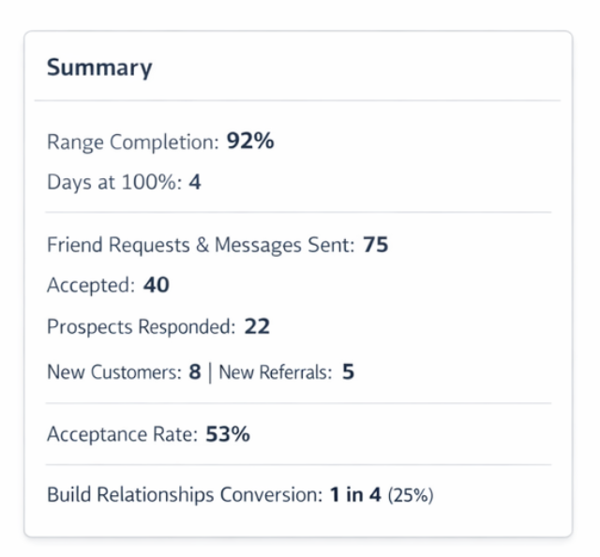

Range Completion % Rule
Range completion % =
Average of daily_completion_percent
across days WITH at least one checklist entry.
Do NOT average across empty days.

Days at 100%
Count days where daily_completion_percent == 100.

10) Data Architecture
Table: checklist_entries
Each record = one user, one date, one task.
Fields:
id
user_id
date_key (YYYY-MM-DD normalized to user timezone)
task_key
value_number (nullable int)
value_boolean (nullable bool)
source_type enum:
- manual
- auto_find_prospects
created_at
updated_at
updated_by
Use normalized records.
Do NOT store JSON blob per day.
Derived values are NOT stored.

11) Task Key List
Find Prospects (auto):
find_prospects_friend_requests_sent
find_prospects_accepted
Build Relationships:
build_relationships_rebuild_relationship
build_relationships_prospect
build_relationships_prospects_responded
build_relationships_follow_up_after_process
build_relationships_final_follow_up
Stay Connected:
stay_connected_personal_post
stay_connected_message_engaged_personal_post
stay_connected_business_post
stay_connected_message_engaged_business_post
stay_connected_reply_to_stories
stay_connected_comment_friends_posts
stay_connected_notifications
stay_connected_birthdays
Facebook Group:
facebook_group_post
facebook_group_comment_on_posts
Growth:
new_business_new_customers
new_business_new_referrals
Derived (NOT stored):
daily_completion_percent
range_completion_percent
acceptance rate
1 in X display

12) Acceptance Criteria
User can:
- Log today’s checklist values.
- Enter 0 to count as completion.
- Leave blank to remain incomplete.
- Have auto-fed Find Prospects rows counted toward completion.
- Edit any past date.
- See completion % based on 19-task rule.
- See static “System Complete Today” label when 100%.
- See calm confirmation toast only on manual save.
- See acceptance rate as percent.
- See Build Relationships conversion as “1 in X (Y%)”.
- See 0% when denominator = 0.

—----------------------------------
New Dashboard Design - Update Success Snapshot Section:

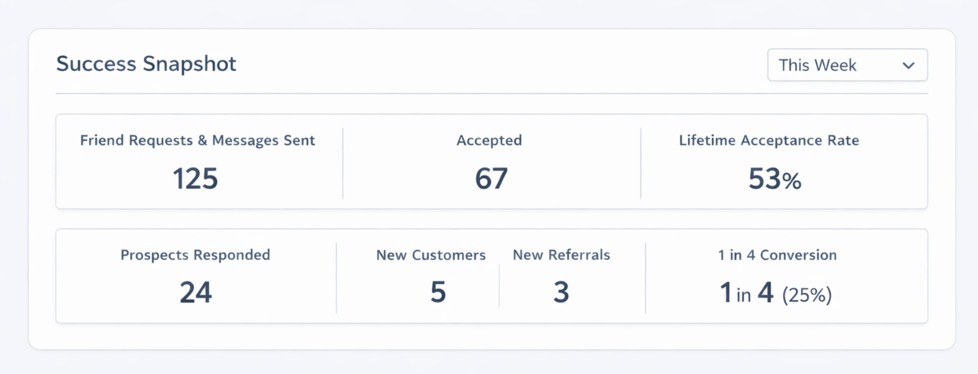

1 in 4 Conversion in grey change to Lifetime Conversion Rate

I believe we said to make Lifetime the default for all fitlers with new upgrade, so do that here as well.

Next to This Week text insert Filter List (like it currently is). This only filters list for friend requests and messages sent, accepted, acceptance rate (as it’s currently programmed)

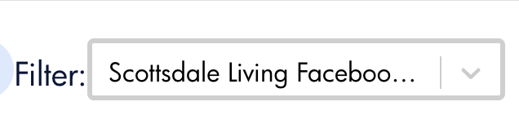
Change the word Filter to Select Prospect List

_____________________________
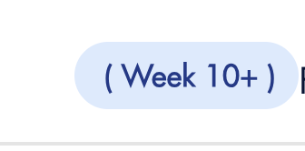

Remove this from dashboard. With auto gone, this is no longer needed.

________________________

Navigation Order
- Dashboard
- Checklist
- Find Prospects (formerly called Connections)
- Prospect Lists (formerly called Outreach)
- Training (formerly called System)
- Referral (formerly called Share)
___________________________

First time login → Training tab

After first time → Checklist tab (currently dashboard)

____________________________

Redesign of dashboard page is underway.

